Question 1: What happens to default-route previously set on Cafe01 router when ISP router is disconnected.
Investigation:
Before removal:
  - “Show ip route” states “Gateway of last resort is 216.0.5.1 to network 0.0.0.0” and “S* 0.0.0.0/0 [1/0] via 216.0.5.1” showing default-gateway is currently active and statically set.
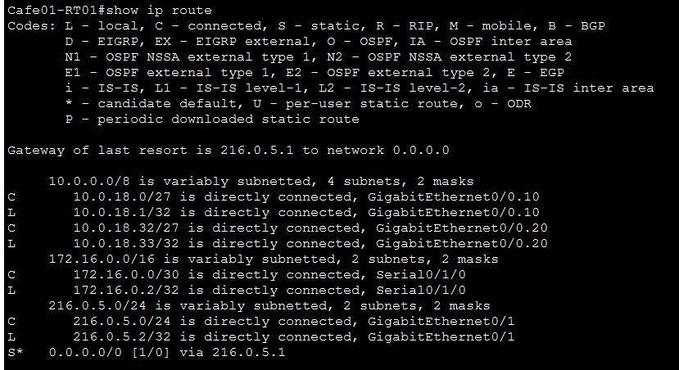
  - “Show run” states “ip route 0.0.0.0 0.0.0.0 216.0.5.1” showing default-route set up

After Removal:
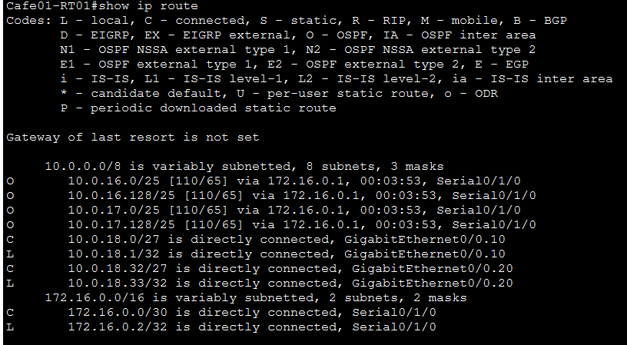
- “Show IP route” states “Gateway of last resort is not set” and static route disappeared
- “Show run” states “ip route 0.0.0.0 0.0.0.0 216.0.5.1” showing manually set static route is still in the configuration

Thoughts on reasoning for outcome: Even though a default-gateway was set for the router, because the interface connection to the network became down/disconnected it acted as a regular route in the routing table and disappeared as both “gateway of last resort” and as a statically set listing in the table.

